Brian Mumby
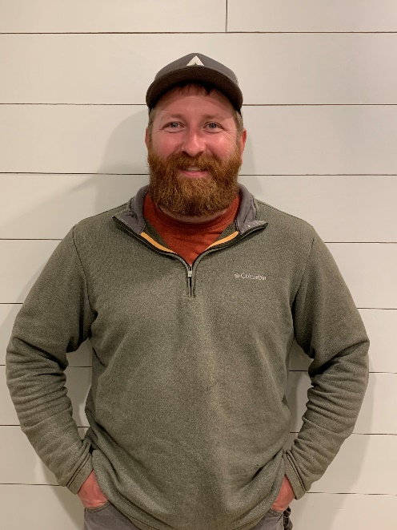
My name is Brian Mumby, I am from Spangle, Washington located in the Northern portion of the Palouse. Growing up I was involved in wrestling, football, 4-H, and FFA. Later, I went on to Spokane Community College where I received a A.A.S. in Natural Resoruces Management with a Forestry Emphisis. I then transferred to the University of Idaho where I received an B.S. in Forest Resources.
During my summers in college I worked for the Washington State DNR, U.S. Forest Service, and Idaho Dapartment of Lands working on engine crews, handcrews, and a timber marking/ cruising crew. Upon Graduation at the University of Idaho I accepted a Forestry Internship with Weyerhaeuser in Coos Bay.
I have been a Forester with Weyerhaeuser for 6 years on the Coos Bay, Coquille, and currently South Valley Tree farm. I recently transitioned into the Forest Enginerring Specialist postion on the South Valley Tree Farm. I am also the Southern Oregon lead for our Enviromental Management Systems (EMS). I have volunteered to help at eduaction days to teach elementary and middle school kids about various forestry subjects.
My wife and I currently live in Eugene with our Dog (Harvey) and two cats. In my spare time I enjoy hiking, backpacking, hunting, and fishing.

